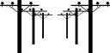 | Electricity  Unscramble the words. | 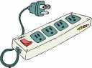

  1. | ampeer
  2. | eiiftr lcelecd
  3. | geatcotenmrle
  4. | cciutri
  5. | ogm saeilenctp
  6. | crtrneu
  7. | crehag
  8. | ndteoeslo
  9. | seuf
  10. | oontucrcd
  11. | trnroeega
  12. | itlcllc earuaipr
  13. | ngiclmitfedea
  14. | entgam
  15. | ritesors
  16. | itcriursecesi
  17. | ssapcom
  18. | hsticw
  19. | ttcetciy ratlieisc
  20. | letcitcriye

